the website is very basic and the home page does not convey very well what SHIFT is and what SHIFT does.

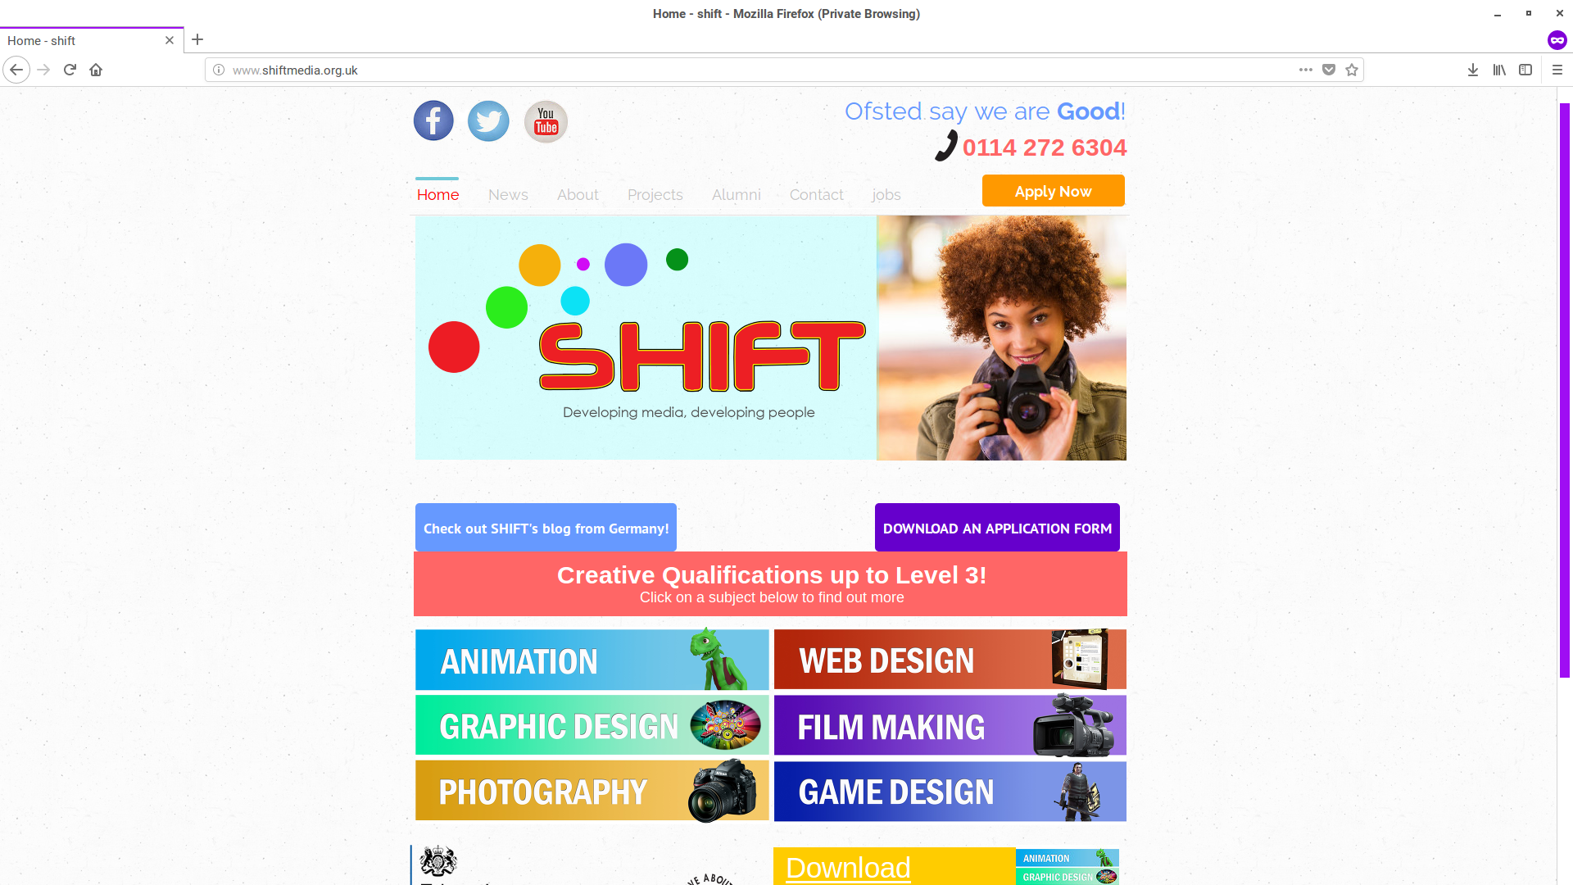
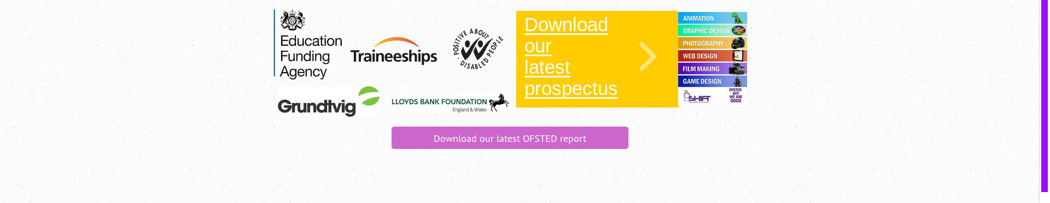
The two screenshots above this text is the homepage for SHIFT Media. I have multiple issues with the layout of the website, the communication of what SHIFT is for an outsider looking in and SHIFT’s core message.

Firstly the layout of the website. The screenshots of the website is exactly how it is, however I did have to crop the photos to avoid image overlapping. The screen resolution when I took the screenshots is 1920x1080.

In the top left hand corner where the average end user will start looking, the SHIFT social media is present, even though the Facebook account & the YouTube account hasn’t been updated in literal years.

In the top right corner, where the average end user would think to look next, there is and I quote “Ofsted said we are Good!” and below is a phone number. One of the people who I asked to have a look at the website they thought that the telephone number was for Ofsted to “find out if they really are as good as they say they are.” Also the apply now button has no context to what the person would be applying for but inference would make me as an end user assume that it signing up for a newsletter of some sort.

The navigation bar is not the worst that I have seen, but it does have a couple of faults as I write about later in the document.

The SHIFT logo takes up two thirds of the limited screen space and on the right hand side, it shows a person that looks like they were taken from a stock image rather than a student volunteering to be in the photo.

The left button “Check out SHIFT’s blog from Germany!” and the right button “DOWNLOAD AN APPLICATION FORM” would seem to be broken links, however, the links for the buttons are just a small slither underneath the buttons. I also noticed that the buttons are rectangles with rounded edges when all of the other images (besides the social media buttons in the top left which are circular) are rectangular with sharp edges instead. Also after digging into SHIFT’s public domain documentation

The box below says about “Creative qualifications up to Level 3!” When SHIFT do not give this kind of education. This shows the disconnect that SHIFT have between them and their website. It also says to “Click on a subject below to find out more” when none of the images are hyperlinked what-so-ever.

On the left hand side, I do not have any qualms with saying who support SHIFT (assuming that is what they are there for) as well as SHIFT having the “Positive about disabled people” there too.

The download for the prospectus on the desktop version is broken due to a 404 error, after further investigation, there are two seperate links, one of them being around the text and the other one being around the picture. The text sends the end user to the prospectus (which is stored in pdf format) however the picture sends the end user to an error page.

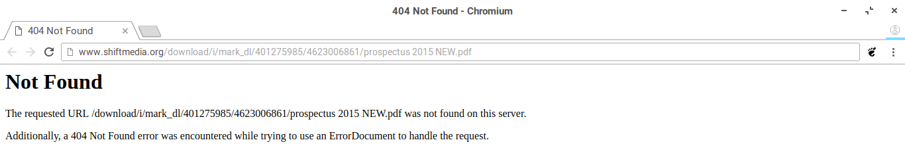
When I loaded the prospectus up, I realised the prospectus was last updated back in 2015! (The year of the document creation is in the filename) Also at the bottom of the page you see the Ofsted report download link that was so highly praised at the top of the website, is also not the most recent version the report as on the Ofsted website.

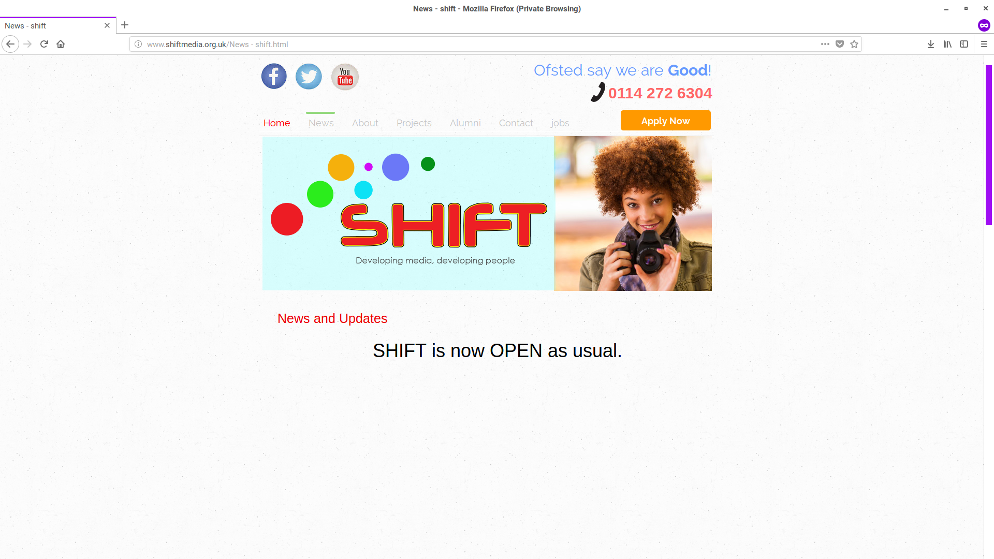
The news page for SHIFT only says that “SHIFT is now OPEN as usual.” There needs to be more information like when the next couple of holidays are, other events that SHIFT might be attending, events that are being hosted by SHIFT are maybe with an added calendar.

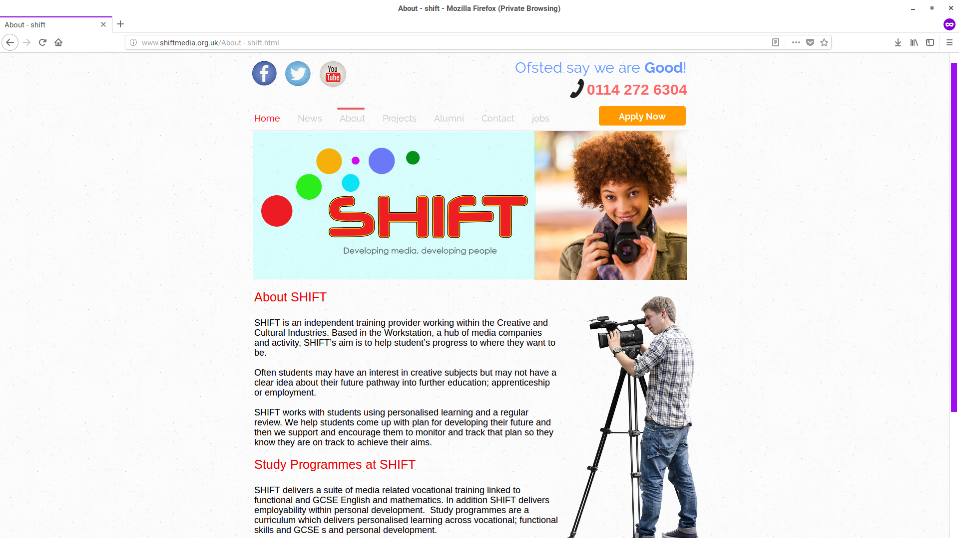
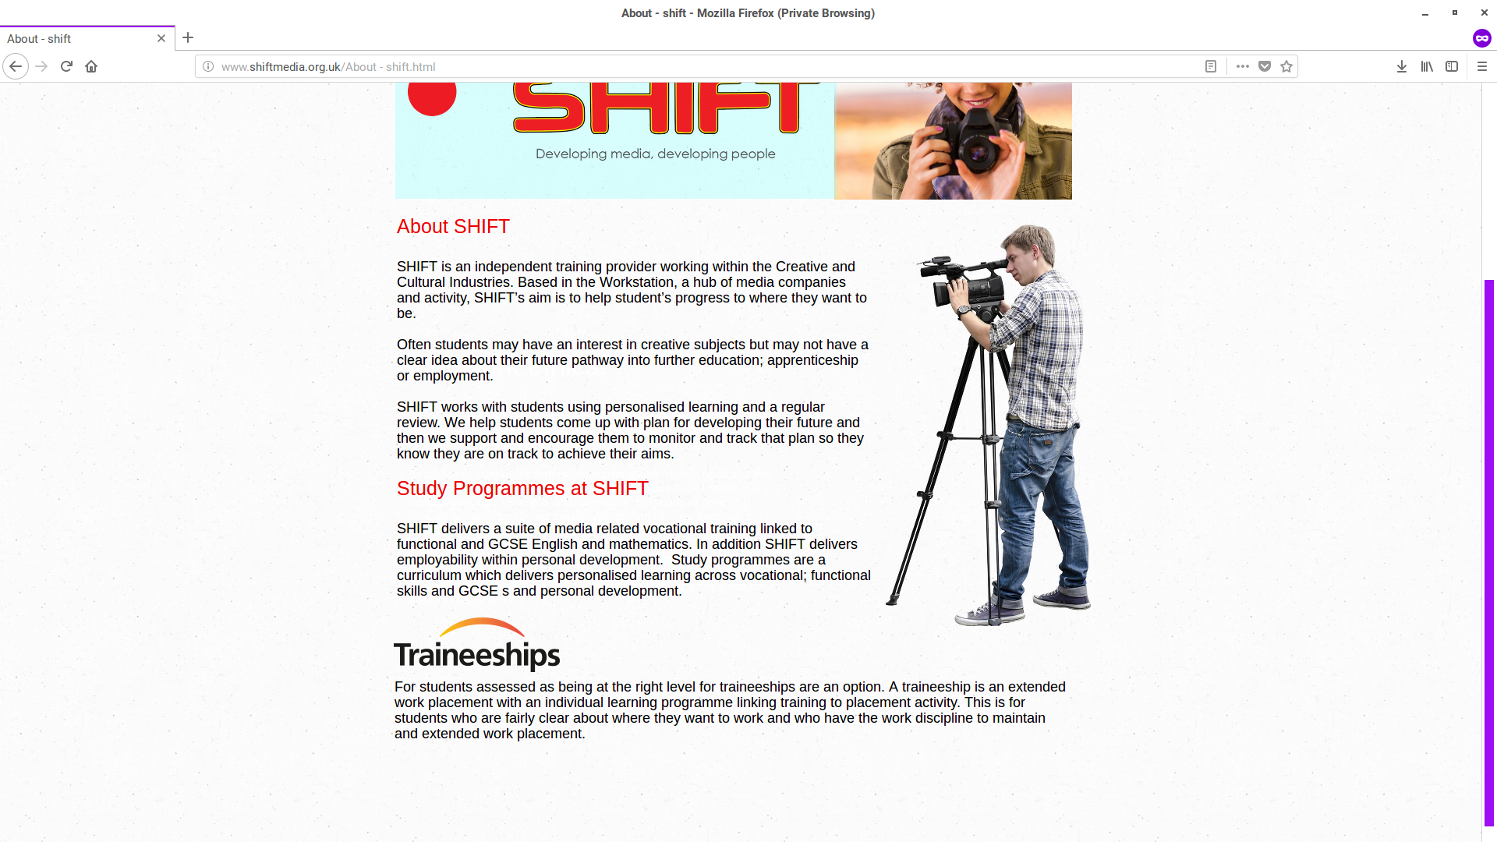
The about page has all of the information about SHIFT and what they do, there isn’t anything that is the problem with this page, aside from the image underneath the navigation bar is copied from the other page when there is no need for it to be there. Also what would be a good idea is to list what qualifications that SHIFT give and at what levels of certification that are. What could be a good edition to this page if the qualifications are added, the critiera documentation for the qualification & maybe a way to upload a unit to the SHIFT server for learners.

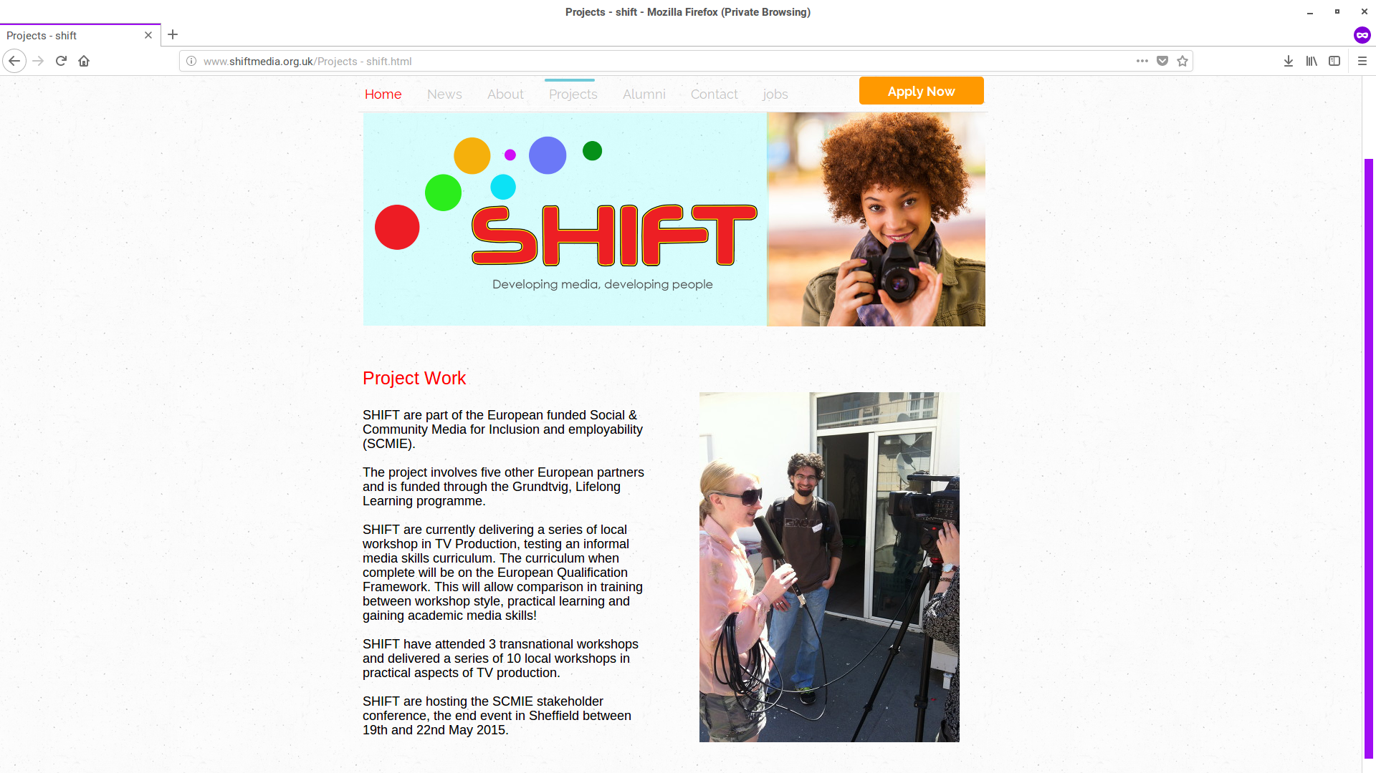
With the Projects page, there is a few inconsistencies with the webpage, there is mention of multiple European creditors, however it is unknown at the time if these creditors will still be helping SHIFT financially due to the political bomb known as Brexit.

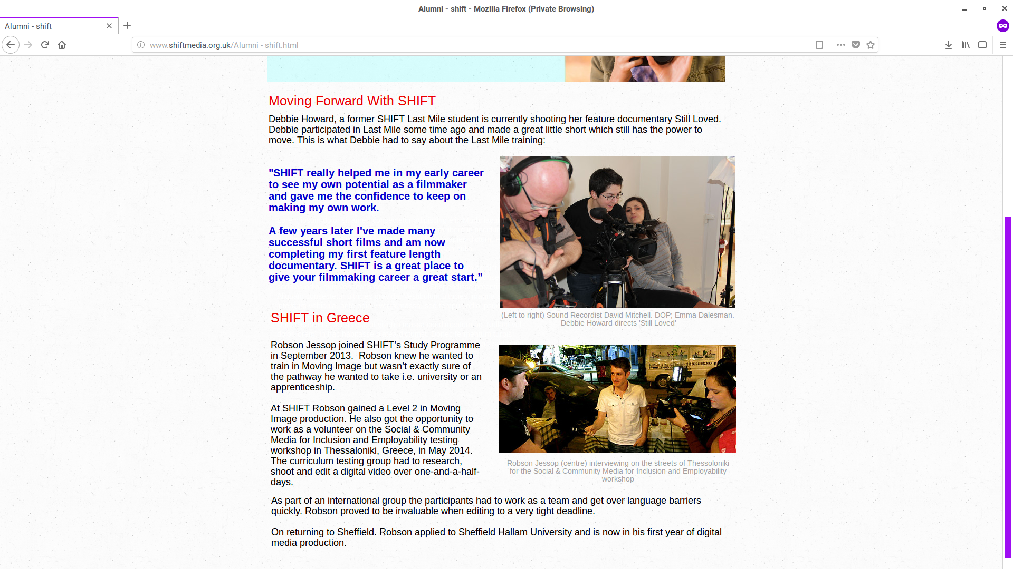

Text
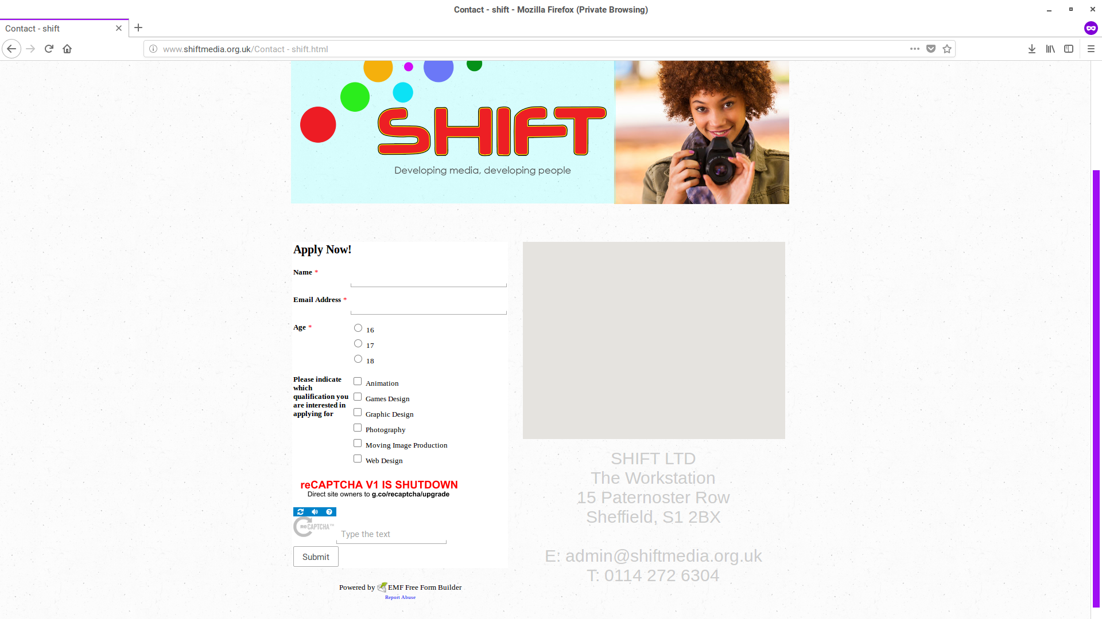
With the contact page on SHIFT’s website, there is a broken captcha link for some reason as I doubt that SHIFT’s website is gaining enough internet traffic to warrant a usage for it. As well the gray square in the right hand column, when it does load, it is an interactive map of the area around SHIFT. I would say have a alternative webpage that has a static image instead so that if a PC fails to load it then the end user can click on a link for a less heavy webpage.

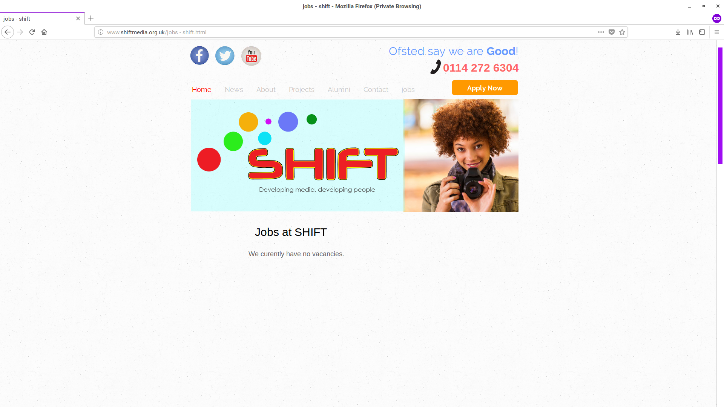
In regards to the Jobs webpage, someone who works at SHIFT noticed the “J” isn’t capitalised and this fact stays constant on all of the webpages.

There is one glaring fact about the website that has been bugging me. A few months ago, there used to be a mobile version of the website that was radically different to the current website but still retained all of the original website pages, just revamped for a mobile device instead of for a desktop PC.

The first website that I will be researching that is not owned by my client is Sheffield College (www.sheffcol.ac.uk/)

The second website that I will be researching is (http://lifelonglearningandskills.org/our-facilities/training-centres/red-tape-central) and due to Red Tape being inside a collection of training providers I will only review Red Tape Central’s page and the home page for the website.

The third and final website that I will be researching is (http://www.ctstraining.co.uk/)

